Tenda AC10-How to set Wireless Repeating?
Model Number: Tenda AC10
Question Classification: Function Setting

Step 1: Open a browser and type http://tendawifi.com in Address Bar, tap “Enter”. Input login password and tap “Login”.

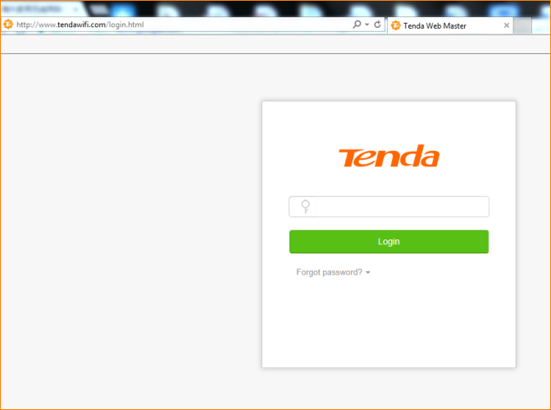

Step 2: Tap “Wireless Settings” > “Wireless Repeating”;

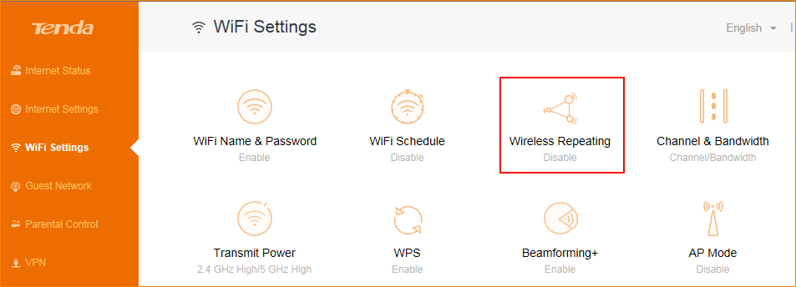

Select the repeating mode "WISP" or "Client + AP" mode, and then tap the refresh icon next to the upper wireless signal name, after scanning the signal, select the wireless signal which you want to extend.

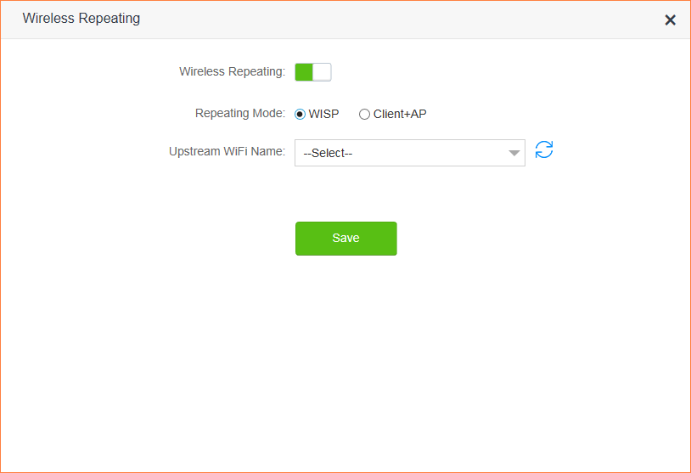
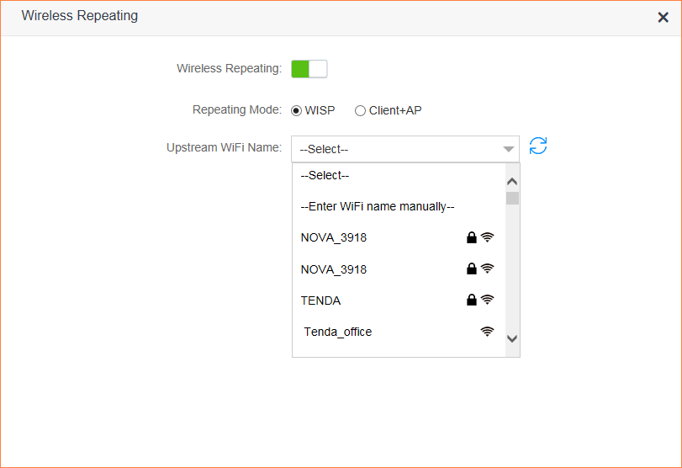

Between the WISP mode and Client + AP mode, the common points: Both of them can expand the WiFi coverage and enhance the Internet experience;
The difference:
WISP: After the repeating is completed, then IP address of the device that connected to AC10 is assigned by AC10;
Client+AP: After the repeating is completed, the IP address of the device connected to AC10 is assigned by the upper router.

Step 3: After the restart is complete, enter tendawifi.com in the browser, log into the router management, open the “Internet Status” menu, and check status as below, indicating that the repeating is successful!

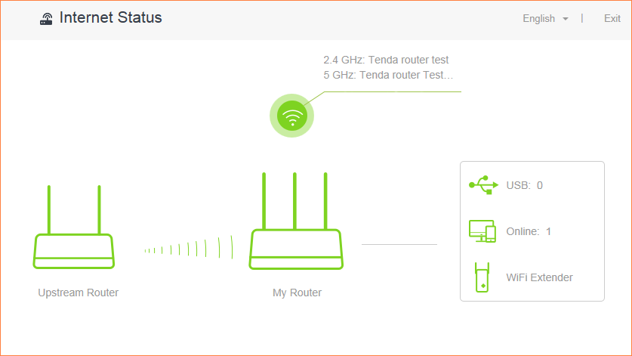

If the wireless signal of the upper router is hidden, please follow these steps:
1. Turn on the “Wireless Repeating”, select the “Repeating mode”, and then open upstream WiFi Name column and select “Enter WiFi name manually”;
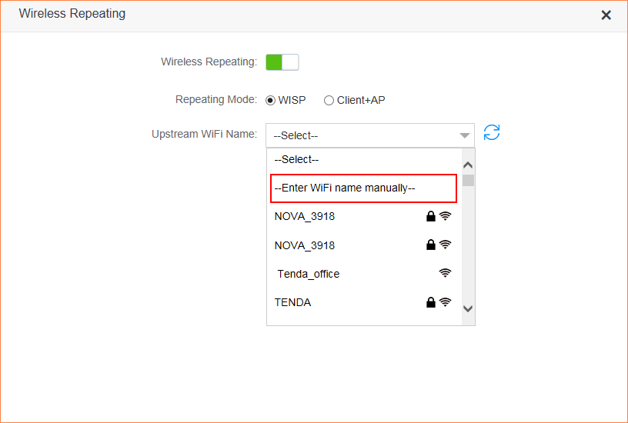

Note:
- The following items must be input with the same information as the upper wireless signal. Otherwise, the repeating will fail. Then tap “Save”, the router will automatically restart after saving.
- WiFi Name: If the upper WiFi name contains uppercase and lowercase letters and symbols, please make sure the input is correct;
- Frequency Band: To confirm the upper wireless signal belongs to 2.4G or 5G, please select the correct one;
- The Encryption mode and Encryption Algorithm: Select the same encryption mode and Encryption Algorithm as the upper wireless signal.
- Upstream WiFi signal: Enter the password of the upper wireless signal, please input it correctly;
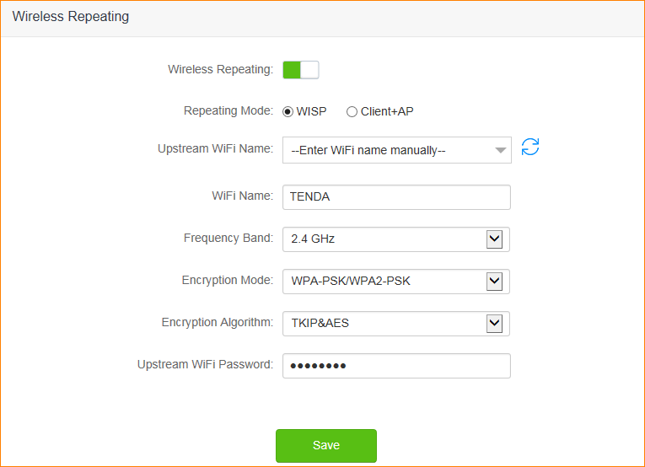

Step 4: After the restart is complete, enter tendawifi.com in the browser, log into the router management, open the “Internet Status” menu, and check status as below, indicating that the repeating is successful!

